REGISTRATION FORM

3rd National Conference on

Recent Advances in Sciences & Technology (NCRAST-2017)
Last Date for Paper Submission: 25 October 2017
Acceptance Notification: 01 November 2017
Author Registration: 10 November 2017
Conference: 11-12 November 2017

(Upload your Paper) Conference URL: https://goo.gl/SLzsuw

Personal Details

Name: ______________________________________________________ ____________________ ________

Sex: M /F ____________________
Age:_________________
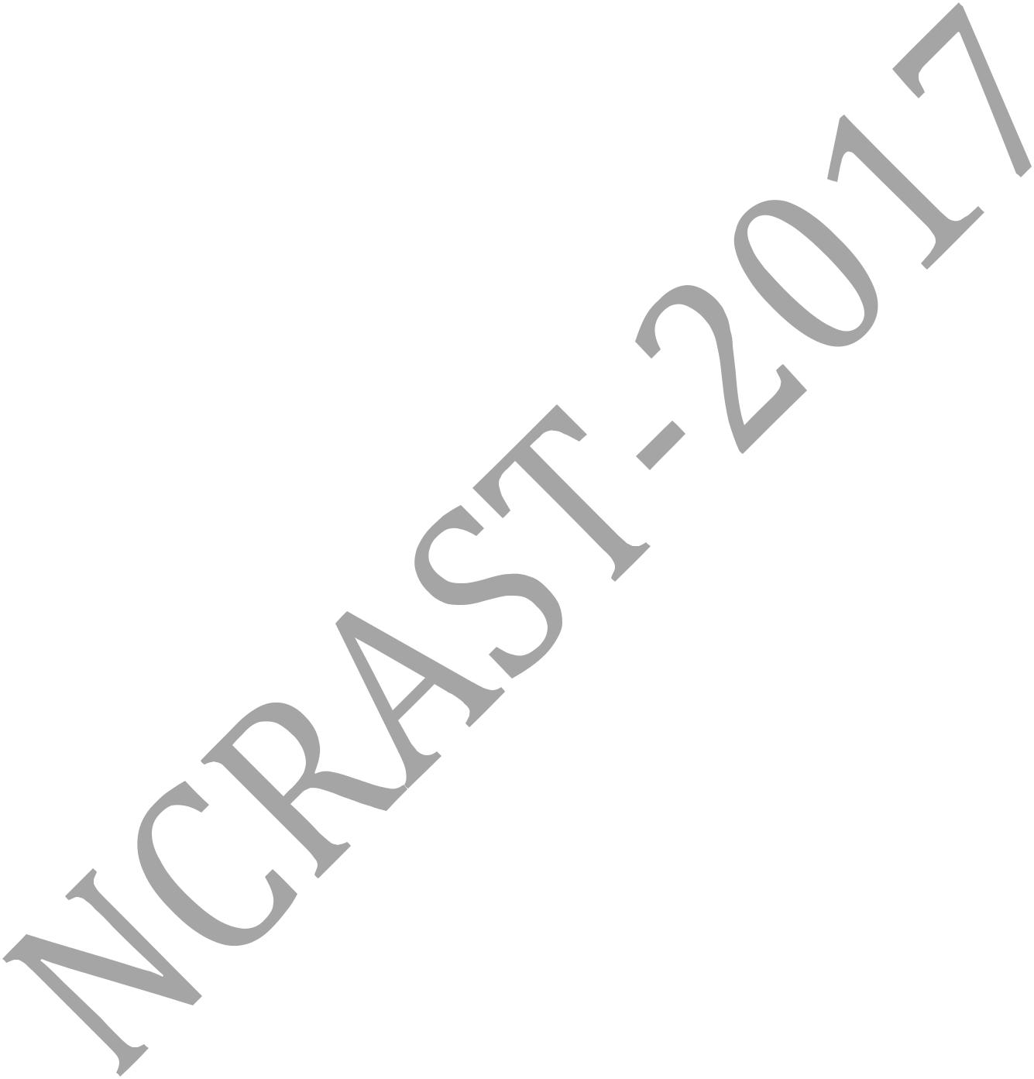
Organization: _______________ ______________________________________________________________ Position/ Designation: ________ __ _______________________ ____________________________________ Mailing Address: ____________ _________________________ ____________________________________ _________________ _________________________ ____________________________________ Telephone: (Off.) ___________ _____(Res) ___________________ (Mob)____________________________

Email: _______________________________________________________________________________

Registration Category (General / Student/ Industry/ Attending): _______________________________________

Whether accommodation required: Yes/No _________________ ____________________________________

Accompanying persons (if any, with name(s) & relationship): _____ ____________________________________

__________________________________________________________________________________________

NOTE: Please include charges for each accompanying persons.

Registration Fees Details (The registration fee is either paid by Demand Draft or by Bank Transfer or on

the spot at Conference Venue):

Demand Draft / Bank Transfer / On the spot

Demand Draft No ____________ _________________________ ____________________________________

(Demand Draft in favour of “Director SIT Pithoragarh” payable at “Pithoragarh” and submitted at the Conference Venue)

Amount: ______________Dated: ____________ Bank on which drawn:________________________________

Bank Transfer Details (In favor of “Director SIT, Pithoragarh” A/C No.: 32041922883, State Bank of India,

Pithoragarh, Branch Code: 000700, NEFT/RTGS/IFS Code : SBIN0000700, MICR Code : 262002999)

Bank Transfer Ref. No..: ____________________________Payment ID: ______________________________

Dated:_________________________, Amount:____________________________

(A jpg image /photo copy of the receipt generated from Bank Transfer must be attached and sent along with this form)

Traveling schedule

Arrival: Date: __________ ______________________Timing:__________________________________

Departure: Date: __________ ______________________Timing:__________________________________

Title of talk/ paper to be presented in NCRAST-2017 _________ ____________________________________

__________ _______________ _________________________ ____________________________________

__________________________________________________________________________________________

Place: _______________________ Date: _____________________

Signature: ______________

Registration Form for 3rd National Conference on Recent Advances in Sciences & Technology (NCRAST-2017)

Organized by

Seemant Institute Of Technology
(A Constituent Institute of UTU, Dehradun)
Pithoragarh- 262 501, Uttarakhand
Email ID: ncrast.2017@gmail.com

Media Resource Partner

Tech Counsellor
It's all in Engineering
Email ID: info@techcounsellor.com

URL FOR Conference: http://www.techcounsellor.com/ncrast2017/

